DOC Agility is pleased to announce the 2020 AAC Ontario East Regional Championships
Friday June 26th to Sunday June 28th, 2020
(Closing date: Sunday May 3rd, 2020)
To be held outdoors in fully fenced grass rings at Orono Fairgrounds, Orono, ON
Judges: Yanick Villeneuve, Sharon Ransom & Brian Wickenheiser
Regional Events (2 Jumpers, 2 Standards, 2 Gambles), Warm up round, 2 Sanctioned Steeplechase & Steeplechase Finals
To stay up to date on all information, please keep an eye on the Website and the Facebook event page.
-----------------------------------------------------------------------------------------------------------
If you have any questions please contact 2020envision@dogsoncampus.com
Tentative Schedule of Events
Friday | Warm-up Round  Steeplechase 1  Steeplechase 2  Steeplechase Finals
Saturday | Jumpers 1  Standard 1  Gamble 1  Barbecue Dinner
Sunday | Jumper 2  Standard 2  Gamble 2  Awards

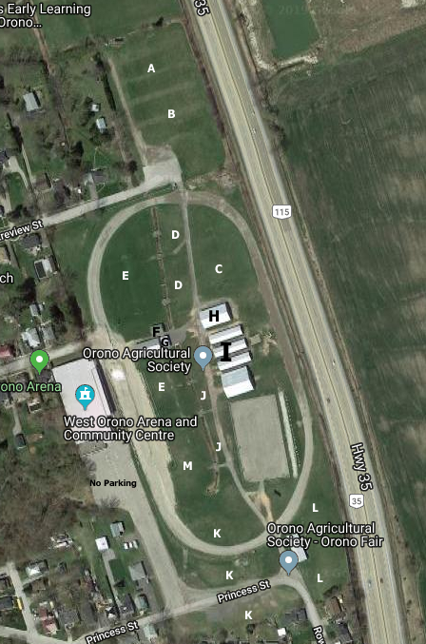 | Tentative Site Map  A – Ring 3  B – Ring 2  C – Ring 1  D – Vendors  E – Crating (Shade tents only)  F – Concession Stand  G – Washroom  H – Registration, ect.  I – Covered & Powered Crating  J – Park & Crate  K – Parking  L – Dry camping  M – off leash  Orono Fairgrounds is located off Hwy 115/35 and is easily accessible from the 401 and 407. East of Toronto, and west of Kingston.
Friday Events
Warm up rounds: Tunnels contacts and weaves will be used in the ring. You will have 2 minutes in the ring. Toys and food treats will be allowed. Any dog eligible to compete may enter.
Steeplechase 1 & 2: 2 rounds of AAC sanctioned Steeplechase rounds. Any dog who is eligible to compete may enter these rounds. You do not need to be from East region to enter.
Steeplechase Finals: The winners of rounds 1 & 2, as well as the top 50% of overall combined score between the 2 rounds, with a minimum of 2 and a maximum of 10, will move on to the Steeplechase finals. Winners of the finals will be awarded $5 for every run entered in their division in rounds 1 and 2. Must be entered in both rounds to qualify for finals, even if you win on.
Information
Concession: There is a concession booth on site run by the Brownies that will offer food for purchase.
Barbecue Dinner: Barbecue dinner tickets are for sale. Cooked by Chef Chris. This will feature yummy food and a vegetarian option.
Crating: There are 3 crating options available. Tent crating, crating from your car (tents also allowed), and covered crating. At a cost of $30 per stall for the weekend, the covered crating are lean-to type buildings, featuring 10x10 stalls and electrical outlets. Stalls can be shared.
Clothing: Every handler will receive a unisex cotton T-shirt. Julie Sungaila-Needham of Need Some Sun will have other merchandise available for purchase. Please see the form near the end of the premium for more details.
Photographer: Karie Elizabeth Photography will be taking pictures this year, please see the form near the end of the premium for more details.
Vendors: If you are interested in setting up a booth, please contact Cindy at training@dogsoncampus.com
Volunteering: For any event this size to run efficiently, we need lots of volunteers! If you or a friend would like to help out, please contact Judy at jvontreg2020@gmail.com
Equipment - All our contact equipment is fully rubberized. Break Away Tire, Electronic Timing will be used.

Awards - For Friday, all dogs with a qualifying score will be awarded a qualifying ribbon. All titling dogs will receive a ribbon. Ribbons will be awarded from first to fourth place in each height division. For the Regional events Rosettes and Trophies will be awarded to the Regional Champions. Ribbons for 1st through 6” place in each category and jump height for each of the 6 Regional events, as well as Qualifying ribbons for those teams that earn 350pts. Saturday’s individual placements will be available after events are complete, and may be picked up on Sunday. Sunday’s ribbons will be available after the awards ceremony. An overall Regional Champion for each 4”, 8”, 12”, 16”, 20” and 24” category (Regular, Specials, Veterans and Double Drop Vets) will be awarded.

Confirmations - All confirmations will be e-mailed and/or posted on the website. Please submit a legible e-mail address.
Sponsorship – We are still looking for sponsors. If you would like a sponsorship package, please contact Lisa at spotdogs13@gmail.com
Security – There will be security onsite overnight, but anything left overnight will be at your own risk.
Camping – There are limited unserviced camping spots available. Please see the order form near the end of the premium for more details. A couple nearby campgrounds are listed in the accommodations.
Raffle – There will be a raffle at regionals. Funds raised will go back into Regional expenses. Please contact sgtwoof@sympatico,ca if you wish to add an item to the raffle.
Accommodations
There are a lot of towns with in a half hour drive, from Whitby to Peterborough to Cobourg. This is just a small list of places, please feel free to shop around, and share your finds if you find something good not listed here.
Hotel / Motel | Cost | Time:  Minutes | Book a block? | Waive Pet fee | Discount
Best Western  Bowmanville  905-623-8500  160 Liberty Street South  Group Name:  O.E.R.A.C. – Dog Agility | 169.00  + tax | 13 mins | 5 rooms reserved  Only 5 pet rooms | No | No
Darlington Provincial  Park  905-436-2036  Bowmanville |  | 20 mins | Camping
Cedar Valley Resort  cvalley@netrover.com  905-786-2562  1-800-333-6989  Orono |  | 11 mins | Camping
Holiday Inn Bowmanville  1-877-660-8550  905-697-8089  37 Spicer Square  Group name  Engelage Teresa  Ontario East Regional Competition | 164.00 | 13 mins | Contract signed  20 – Double/queen bed 164.00 | N0 | No
Quality inn Peterborough  705-748-6801  Fax 705-748-6254  Group Name  Ontario East Regional Competition  Account # 3880167 | 115.00 | 28 mins | 25-Double Bed -115.00  10 – King 115.00  Fdm@qualityinnpeterborough  Contract signed | Pets only on first floor | Not  sure
Super 8 Wyndham  Peterborough  705-876-8898  Group Name  Ontario East Regional  Competition | 135  0r  145 | 28 mins | gm@super8peterborough.com  10 Rooms on hold  4 rooms - 2 queen 135.00  2 rooms - Family Suite + 2 bunk beds 145.00  3 rooms - Junior suite King and sofa bed – 145.00  1 room – executive suite King and sofa bed 135.00 | No | N0
Quality Suites  Whitby  905-432-8800  1700 Consumers  Drive Whitby  Group Name :  Ontario East Regional Competition  Group Acct #  3869278 | 119  Or  129 | 28 | 20 Room Block  10 King 129.00  10 2 double beds – 119  Group Name  Ontario East Regional Competition | Yes | yes
Motel 6  Whitby  905-665-8883  165 consumers Drive. Whitby  Group # GPTS5T31EA | 109  0r  115 | 28 | Booking Teresa# 800-544-4866  20 room block 109 +tax  10-1 queen – 109.99 +tax (1 person) 115.99 – 2 people  10 – 2 double – 109.99 +tax – 1 person 115.99 – 2 people | Yes | yes
Hampton Inn  Peterborough  705-270-6280 | 128 | 25
Peterborough Inn & Suites Hotel  705-876-6665 | 123 | 30 | frontdesk@peterboroughinn.com  emailed X2
Holiday inn Peterborough | 181 | 32
Eligibility
All dogs that have an ID# with AAC are eligible to compete at the Provincial level. The event is open to all dogs capable of demonstrating the elements of agility, control and the mental and physical ability to carry out the required tests. Competitors, through submission of entry acknowledge that they are knowledgeable of the rules and regulations of AAC.
Dogs less than 18 months of age, bitches in season or in an advanced state of pregnancy, or dogs suffering from any injury or illness that affect the dog’s physical or mental performance, and any dog which demonstrates signs of aggression towards people or other dogs shall not be permitted to compete in a Regional Agility Championships.
Regional Championships Applicants must supply AAC ID# on their entry form. Regional Championships are subject to all AAC rules and regulations except where indicated in the Regional and National Rules and Guidelines. All current members of AAC must receive a discount on their Regional entry fee compared to the entry fee for non-members
Safety at this event shall be of foremost consideration at all times. Handlers through submissions of entry at this event shall take full responsibility for themselves, and the actions of their children and their dogs. No leads, collars, food or toys shall be permitted in the ring during the Regional Saturday and Sunday events as per AAC rules. Food and toys will be allowed during the warm up runs on Friday ONLY, and under the following conditions:
- that allowing food does not contravene the site and/or facility rules
- toys should be in a good state of repair
- toys may not contain audible squeakers or noise makers
- handlers are permitted to throw toys to the dog or tug with their dog
- training aids (e.g. clickers, stride regulators, target plates) are not allowed
- food may not be thrown or dropped, it must only be fed from the hand or container
No entry fee will be refunded if the Event cannot open or be completed by reason of riots, civil disturbances, fire, act of god, public emergency, strike, thunder and lightning or any other cause beyond the control of the organizers.
Dogs must remain on leash and under control at ALL times when not competing or warming up or in designated off-leash areas. Dogs must not be left unattended except in the designated kenneling area and your dog(s) must be properly secured. Dogs must be exercised in the designated areas only. You must pick up after your dog on the show grounds and at your hotel/motel. Anyone found not picking up will be excused from the trial site with NO refund of entry.

All dogs must run at a jump height at which they would be eligible to compete in an AAC- sanctioned trial for the class in which they are competing, to a maximum of 24" in regular classes and a maximum of 20" in specials and veterans classes.
Competitors shall have the right to video tape portions of this event for their personal use only. No portions of this event may be taped for commercial purposes without the permission of the AAC.
REGIONAL CHAMPIONSHIP EVENTS
Each Regional will consist of 6 qualifying runs, which shall include; 2 standards, 2 Gamblers and 2 jumpers courses. Dogs must be entered and run all 6 classes to be eligible to place in the Regional Championships. All dogs not having a fully signed ID card shall be measured in on the first day of the event by the officiating Judge(s) and this measurement shall not be used on their ID card. A person may enter more than one dog but under no circumstances may more than one person enter the same dog. Dogs shall run every round, there will be no dismissing of dogs except for aggression, elimination in the ring, leaving the ring, un-sportsman like behaviour or dogs out of control.
REGIONALS RULES (Abbreviated version)
Complete rules can be found on the AAC website:
https://aac.ca/en/node/718 (please review the Regional Rules documents as posted online – below is ONLY a few rules of note) – it is the competitor’s responsibility to be familiar with AAC Regional Rules for competition at this event.
The Agility Association of Canada’s Regional Championships are a prestigious event unto themselves and a steppingstone to the AAC National Championships. Dogs must qualify at their Regional Championships to be eligible to enter the AAC National Competition.
JUDGING RULES
For standard/jumpers rounds the following modifications to the existing AAC Rules for scoring a Master Standard/Jumpers rounds apply:
- Three refusals will not result in elimination (all refusals 5 faults no max.)
- Wrong Course will not result in elimination (all instances 20 faults no max.)
- Non-completion will not result in elimination (all instances 20 faults no max.)
- Elimination or dismissal will result in dog not scoring any points for that event.
- Competitors that do not run in an event will score no points for that event
- If a handler intentionally directs a dog to repeat an obstacle, the run will score no points and the dog and handler must leave the course at standard course time
For Gambler Rounds, judged at Masters Gamblers rules, except:
- All wrong/off courses after the closing gamble has begun (after the first gamble obstacle has been attempted) will be recorded as a failure to complete the final gamble.
- There will be no refusals called in either mini gambles or final gamble.
- If a dog takes two gamble obstacles in sequential order in the opening sequence the judge shall blow the whistle and the competitor shall retain all opening points up to that time.
- If the handler purposely touches the dog as a form of encouragement or reward in the opening sequence, the run instantly becomes an FEO run and scores zero points.
- The judge may inform the handler that the signal to start the closing gamble has sounded and the handler must attempt the closing gamble to retain points. They may still attempt the closing gamble after final signal (indicating allotted gamble time is up) in order to retain opening points.

OFFICIAL ENTRY FORM
AAC Sanctioned Regional Championship Event
Mailed entries:
Postmarked by May 3rd, 2020. No late entries
c/o Amanda Wood, 718 Krosno Blvd, Pickering, On, L1W 1G3.
Cheque payable to Cindy Boht
Emailed Entries and e-transfers:
2020envision@dogsoncampus.com use password Regionals
- At this AAC sanctioned event, AAC members receive a discount. You must provide your current AAC membership number to qualify for the discounted rate. Your AAC number is NOT the AAC Dog number, but the number issued after you pay your annual dues.
- Entries must be received with all information complete, agreement dated and signed, and with the correct fees in order to be valid.
- Withdrawals before closing, for any reason, will receive a full refund
- A refund for withdrawals after closing will only be offered in cases of injury or illness, must include a doctor’s or vet note for the handler or dog, and will be subject to a $10 handling fee.
- There will be no Regional refunds, for any reason, after the first run starts on Saturday morning.
- Competitors will be charged $25 for a dishonoured cheque.
Dog’s Call Name: | Breed:
DOG AAC Reg. #: | Birthdate:
Dog Height: | Height Dog will jump at trial: (circle one) | 4” | 8” | 12” | 16” | 20” | 24”
Circle Dog’s Status: Regular Special Veteran DD Vet Junior Handler?: Y N
Owner/Handler Name:
Address:
City: | Prov/State: PC/Zip:
Phone#: | Email:
Regional Championship Rounds – non-member – First dog (per handler) $155 |  |  |  |  |  |  |  | $
- Member (Must show valid 2019 AAC # __________ ) $135 |  |  |  |  |  |  |  | $
Multiple dog per handler (discount is only for Regional entries does not apply to the first dog) Subtract $10 per dog |  |  |  |  |  |  |  | $ - ( | )
Fri: AAC Sanctioned Steeplechase #1 $20 |  |  |  |  |  |  |  | $
Fri: AAC Sanctioned Steeplechase #2 (must run both to qualify for finals) $20 |  |  |  |  |  |  |  | $
Fri: Warm Up Games: Contacts/Weaves/Tunnels $10 |  |  |  |  |  |  |  | $
T-Shirt size Please indicate a size, no cost
Covered crating fee $30 for the weekend |  |  |  |  |  |  |  | $
BBQ Dinner $25 x # of Tickets ___ |  |  |  |  |  |  |  | $
RV Camping Total: Attach reservation form with entry |  |  |  |  |  |  |  | $
TOTAL ENCLOSED |  |  |  |  |  |  |  | $
Handler Name:
Dog 1 Name: (the “Dog”) AAC Dog ID#:
Dog 2 Name: (the “Dog”) AAC Dog ID#:
Dog 3 Name: (the “Dog”) AAC Dog ID#:
Dog 4 Name: (the “Dog”) AAC Dog ID#:
In consideration of the acceptance of this entry by AAC and ▼[DOC Agility] (the “Organizing Club”) and the opportunity to have the Dog participate, compete in and/or be judged at this event or trial (the “Event”), I, the undersigned, agree as follows:
1. I certify that I am the actual owner of the Dog, or that I am the duly authorized agent of the actual owner of the Dog and that the Dog is not a hazard to persons, property or other dogs.
2. I agree that AAC or the Organizing Club for the Event may refuse my entry for any reason that it deems to be sufficient.
3. I understand and acknowledge that participation in the Event carries certain risks, including, but not limited to injuries (including serous injuries and death) to myself, the Dog, another dog under my control or persons attending as my guests (my “Related Parties”), damage to property and other losses. I waive any and all claims that I have or may have in the future against, and release from all liability and agree not to sue AAC, the Organizing Club or any of the directors, executives, committees, representatives, employees, volunteers or agents of either AAC or the Organizing Club (the “Personnel”) for any injury, death, property damage or other loss that I or my Related Parties sustain due to any cause whatsoever, including negligence, breach of contract, breach of duty, statutory or otherwise, or mistakes or errors of judgment of any kind.
4. I assume full responsibility for the conduct of myself and my Related Parties during the entirety of the Event. I agree to indemnify and save harmless AAC, the Organizing Club and the Personnel from and against any and all claims that may be made against them or costs, fees, expenses or liability (including, without limitation, lawyers’ fees on a solicitor and own client basis) incurred by AAC, the Organizing Club or the Personnel that may arise due to:
(a) any act or omission of myself, my Related Parties or any party for whom I am liable at law; or
(b) aggressive behaviour by the Dog or any other dog under my control.
5. I have read, and do understand the rules of competition and the additional rules (if any) appearing in the trial schedule for the Event, as well as the policies of AAC pertaining to discipline (collectively, the “Rules”). I agree to abide by the Rules and to conduct myself and the Dog in accordance with the Rules. I understand that myself and/or the Dog may be subject to disciplinary procedures or sanctions for breach of the Rules and agree to respect and be bound by any disciplinary decision made by AAC.
6. I understand that AAC and/or the Organizing Club may, in the course of administering the Event or conducting its activities generally, collect, use or disclose my personal information and that any personal information collected, used or disclosed by AAC and/or the Organizing Club will be treated in accordance with AAC policy and applicable privacy and personal information laws. I hereby consent to the collection, use and disclosure by AAC and/or the Organizing Club of my personal information.
Media Release & Rights of Privacy Waiver
I Hereby Grant to AAC and its affiliated companies, representatives, agents and assigns, all rights and permission to use or appropriate his/her and their dog’s name, biography, likeness, photograph, voice, performing persona, or other indicia of identity for broadcast, telecast, cablecast, transmission or distribution in any format or media known now or in the future.
Waiver of Rights to Privacy, Publicity & Personality
Further, I hereby release Agility Association of Canada Inc, and its affiliates, representatives, agents and assigns from any claim or cause of action for invasion of the rights of privacy, right of publicity, right of personality, or any similar rights.
7. I have been given the opportunity to read and understand the terms of this Agreement before signing it, and have in fact done so. I understand that by signing this Agreement, I am restricting my legal rights and I sign this Agreement voluntarily and of my own free will.
Signature:
Parent or Guardian must sign if the Handler is under 18 years of age.
Date (dd/mm/yy):
There are limited unserviced, onsite camping spots. Please contact 2020envision@dogsoncampus.com for more information.
RV OVERNIGHT REGISTRATION FORM
Name:
Email: Phone:
RV DESC. | (include ft)
RV Lic. #

PLEASE CIRCLE WHICH NIGHTS YOU WILL BE CAMPING ONSITE:
No Hookup  $20 per night | THU | FRI | SAT | $20 x = $
License numbers will be used to confirm registration.
Unauthorized vehicles may be subject to a penalty fee or towing.

Special Requests:

AAC Ontario East Regionals
Official Photographer
We are honoured to be at this year’s regionals! Package details this year are
Package 1- $80 5 Hi-Resolution Images
Package 2- $150 15 Hi-Resolution Images
Package 3- $50 5 Web/ Social Only Images
Package 4- $350 Buy All One Dog Package
(multi dog discount)
Package 5- $100 (Collage Digital File Only)
Package 6- $150 Collage Digital File Plus 5 Digital Images

We will not be accepting pre-orders if an injury or something occurs you will not attend or something during the competition then you are not out a prepaid package! We get every dog at these events so we will have everyone covered!
www.kephotography.ca / info@kephotography.ca /(705) 896-1191
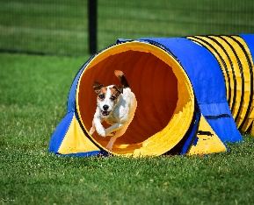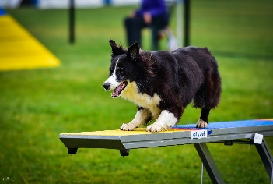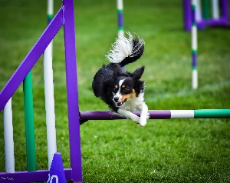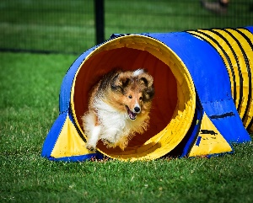
2020 AAC Ontario East Regionals
Commemorative Clothing
Orders accepted until May 15th, 2020

Commemorative clothing available:
- Light weight performance pullover hoodie, ladies and unisex
  - $50 (add names to sleeve ($2 ea) or back ($5 ea))
    - Available in black, red, coal grey, or royal blue

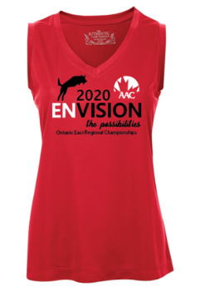

- Moisture wicking ladies v-neck sleeveless tee
  - $25 (add names to back ($5 ea))
    - Available in black, red, coal grey, or royal

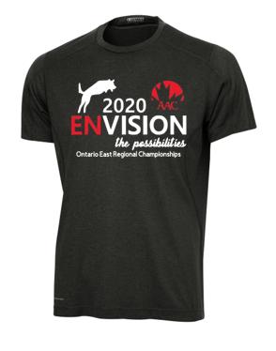
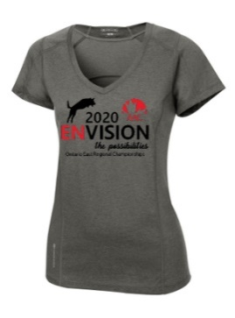

- Performance material tee, ladies and unisex
  - $35 (add names to sleeve ($2 ea) or back ($5 ea))
    - Available in blacktop, ripped red, electric blue, gear grey

- Cotton Twill Ball Cap – one size fits most!
  - $15 (add 1 name to side ($2 ea))
    - Available in black, red, concrete, or royal
    - Adjustable Velcro closure

To order, please visit: https://www.needsomesun.com/aac-ontario-east-clothing

